Project Initialization and Planning Phase

Date | 15 March 2024
Team ID | xxxxxx
Project Name | xxxxxx
Maximum Marks | 3 Marks

Define Problem Statements (Customer Problem Statement Template):



Create a problem statement to understand your customer's point of view. The Customer Problem Statement template helps you focus on what matters to create experiences people will love. A well-articulated customer problem statement allows you and your team to find the ideal solution for your customers' challenges. Throughout the process, you’ll also be able to empathize with your customers, which helps you better understand how they perceive your product or service.

Example:
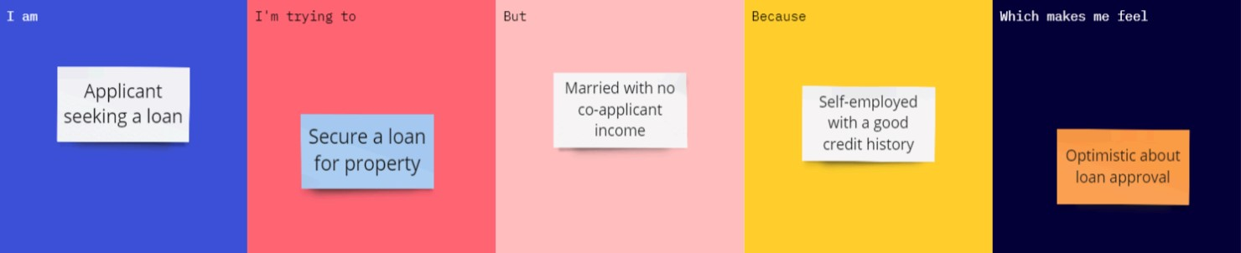

Problem  Statement  (PS) | I am (Customer) | I’m trying  to | But | Because | Which makes me feel
PS-1 | A retail business owner/marketing manager | Place products strategically to increase sales and customer engagement | I don't know which products should be placed together or in premium locations | I don't know which products should be placed together or in premium locations. | Frustrated and unsure about making profitable merchandising decisions

